
Land Information Ontario (LIO) Warehouse
Data Class Name: EcoDistrict
Documentation
Produced by: Information Access and Information Management Policy Unit
Ministry of Natural Resources and Forestry
Date: July 27, 2015

Purpose

This document provides additional information to support the use of geospatial data. The Physical Model Diagram provides a visual representation of the relationships in the data class. The Data Change History lists all the modelling and access changes that have occurred during the lifecycle of the data class. A data description identifying table and field names is available upon request.

Need Assistance?
Please contact LIO Support at lio@ontario.ca or 705-755-1878 if you require help.

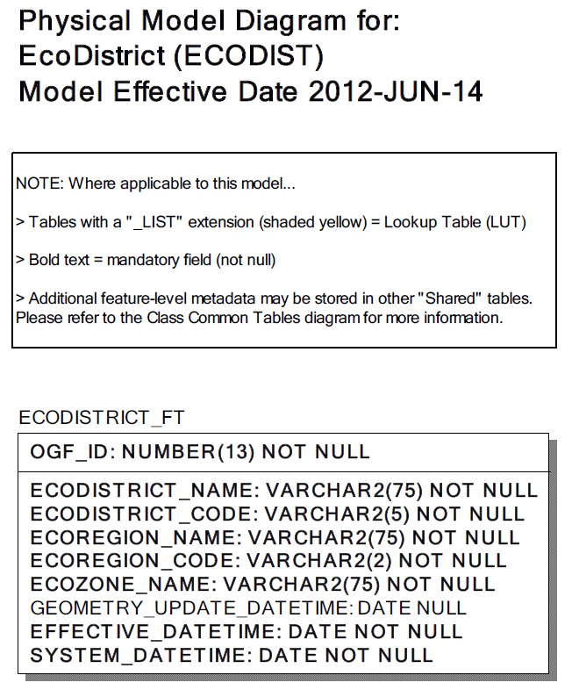
Data Class Change History

Data Class Name: EcoDistrict
Data Class Short Name: ECODISTR
Date  YYYY-MM-DD | Details of Change
2012 | Table added: ECODISTRICT table replaced old ECODIVISION table.  Table dropped: ECODIVISION table was replaced by ECODISTRICT table.  The following Columns were added to ECODISTRICT table:  - ECODISTRICT_CODE  - ECOREGION_NAME  - ECODISTRICT_NAME  - ECOZONE_NAME  - ECOREGION_CODE
2001 | NEW Data Class
Data Description
Please refer to the metadata record for the data description.

